**Generated Report on all Students' Final Marks**

The following data is on all students' final grades. It provides an insight into students' performances in various different classes at the university.

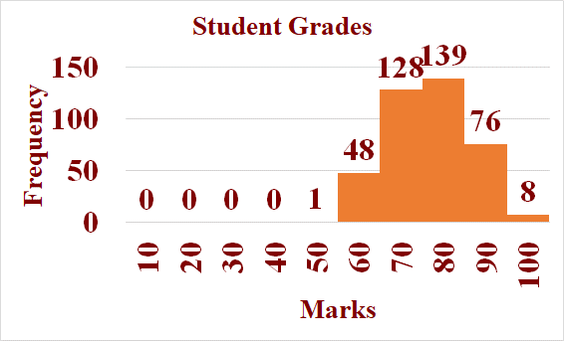

Statistics on marks:

Mean: 71.49375

Median: 71.825

Mode: 68.9

Standard deviation: 9.35476898133981

Min: 49.3

Max: 92.55